Project Design Phase
Solution Architecture
Date | 01-10-2026 | Team ID | SWTID-2026-5415
Project Name | Import Data Using Transform Maps (Spreadsheet) | Maximum Marks | 4 Marks
The architecture bridges the business need and the ServiceNow implementation.
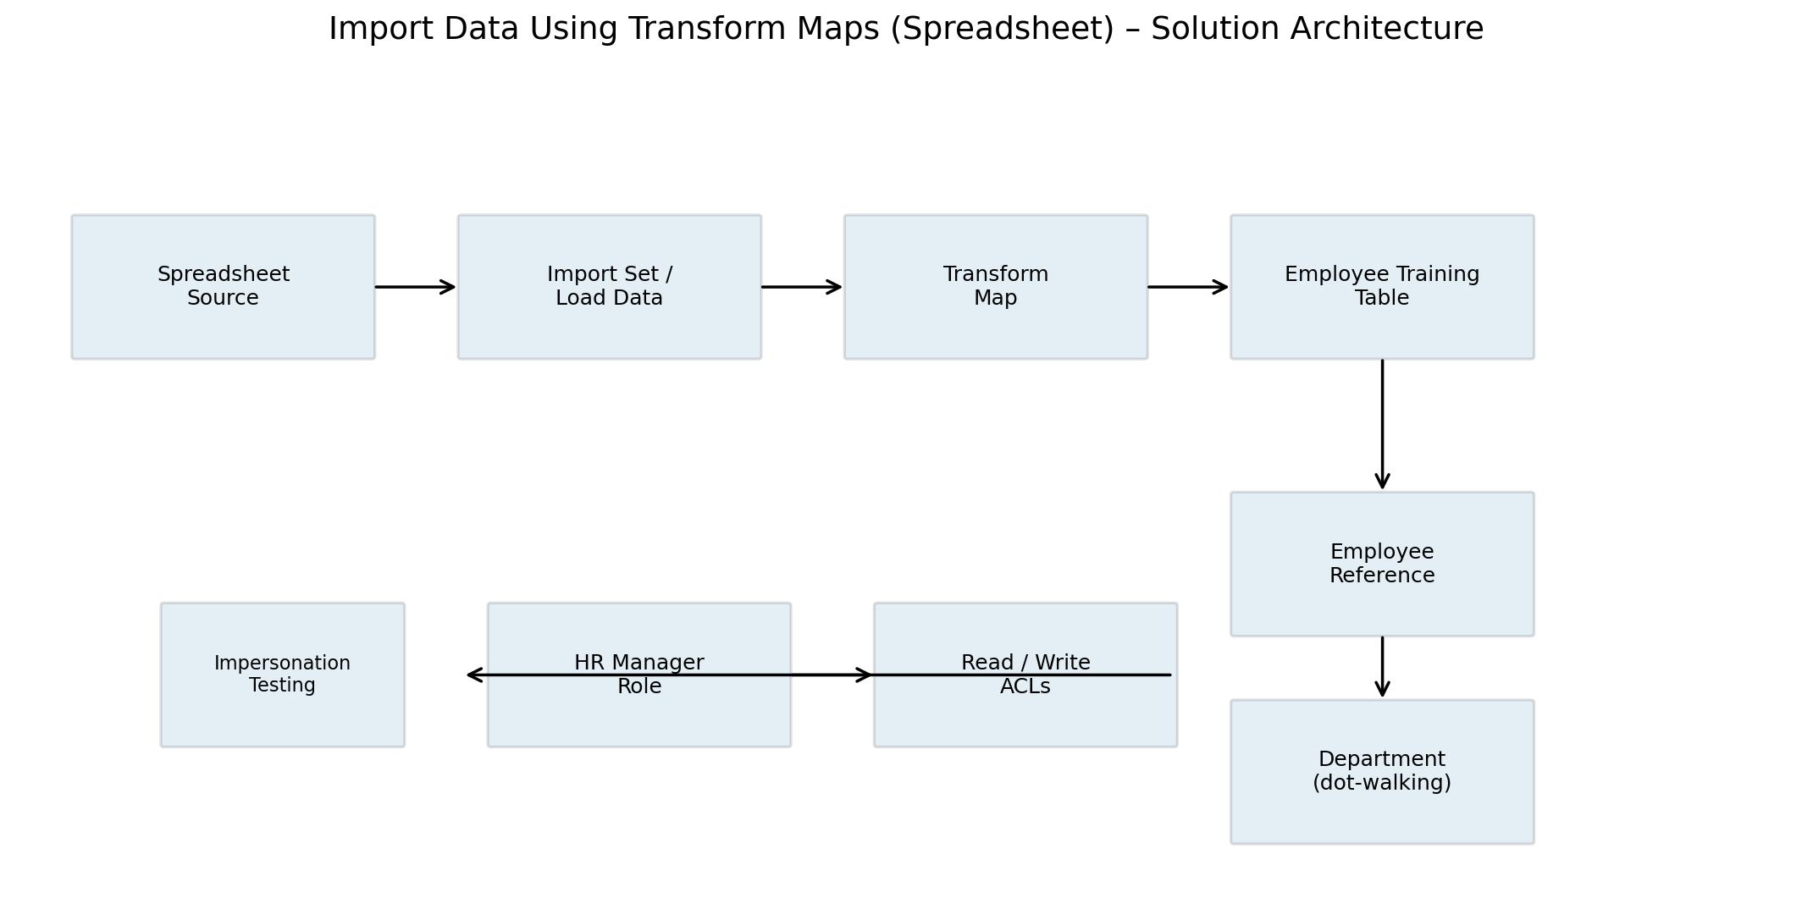

Architecture Components
Layer | Component | Purpose
Source | Spreadsheet | Provides the source records.
Import | Import Set / Load Data | Loads spreadsheet rows into ServiceNow's import process.
Transformation | Transform Map | Maps and transforms source fields.
Data | Target table | Stores transformed records.
Relationship | Employee reference | Connects each record to an employee.
Related data | Department | Accessed through dot-walking.
Security | Role + Read/Write ACLs | Controls access.
Validation | Impersonate | Checks configured permissions.

